Rider JetBrains

**Vyhody:**

Po zmene branche se okamzite reloadne.

Super callStack na threadech

**Nevyhody:**

Nema OZCode – v mistech kam se nedostanu neni zasednuty

Nevim jak zobrazit properties komponenty z xamlu a zobrazit eventy

Errory v solution exploreru

Nema pin na zalozka s tridama

Resx – neotevre v nejake rozumne editaci ?

**Cara uprostred**

Editor > Color Scheme > General. Then in the new control to the right, open Editor > Guides > Hard wrap guide, and uncheck the checkbox for "Foreground".

**Vyber celeho slova doubleclickem**

Ctrl + Alt + S -> camel



**Resharper KeyMap**

Ctrl +` zvolit

**Comment/ Uncomment**

Ctrl + Shift + /

**Sql cmaraniny**

Alt + Enter -> Disable inspection vlevo na zacatku radku

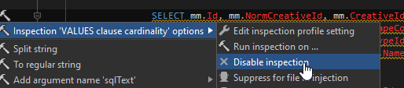

**Jak vymazat cache:**

Ctrl + shift + A -> invalidate cache